First design of the Robot Arm (Very primitive):

Arm design : This is the first design we have made for the Arm, of course it will be subjected to many changes in the future in order to reach its optimised state.

Many of these parts were quickly designed so that we could get an overall idea of what the arm would look like.

Z

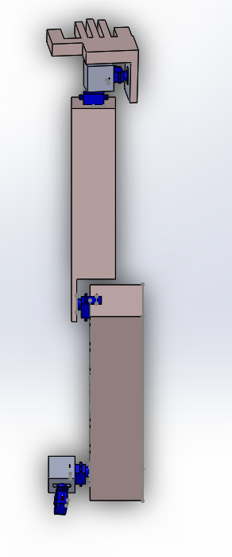

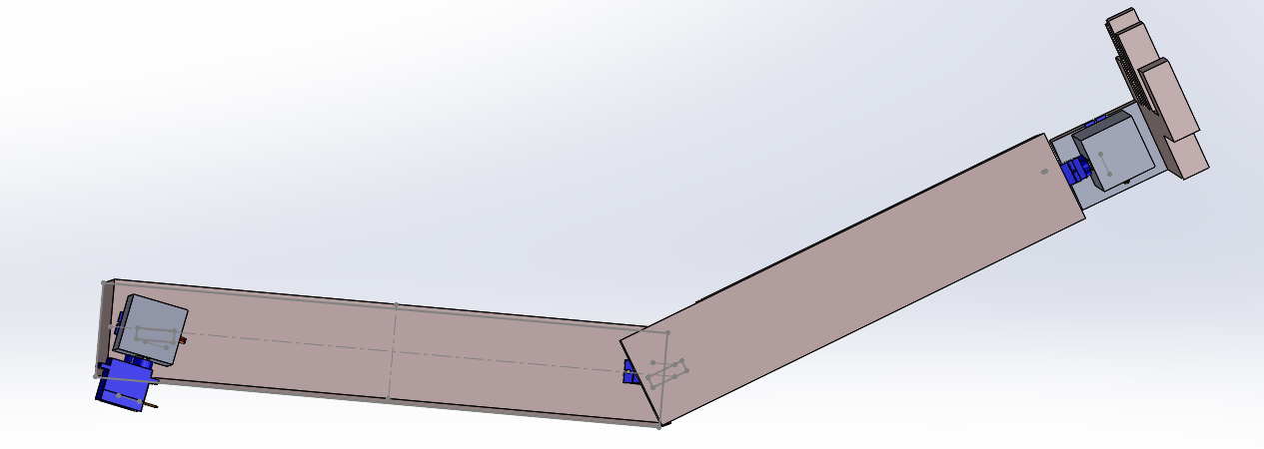

Shape of the Arm: Side and bottom view (point his hand forward not on the side)

y

x

The main components of the arm are the following :

* The hand joint
* The elbow joint
* The shoulder joint

We will go into further details for all 3 joints**, let’s start with the hand joint:**

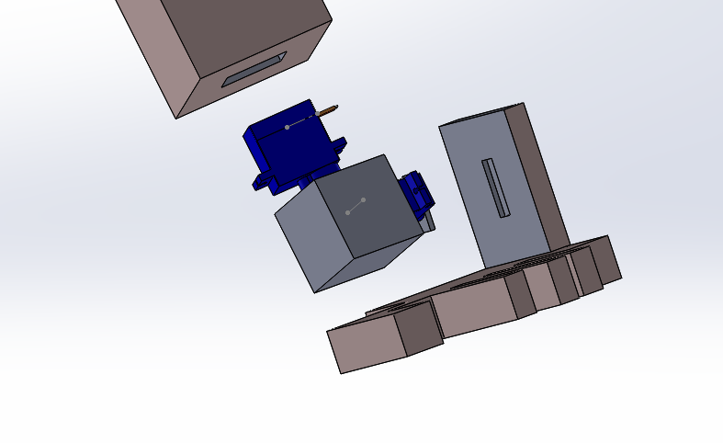

The Hand joint:

The hand joint is comprised of a cube with 2 rectangular holes imbedded in the cube, that can accommodate 2 servos, just like so:

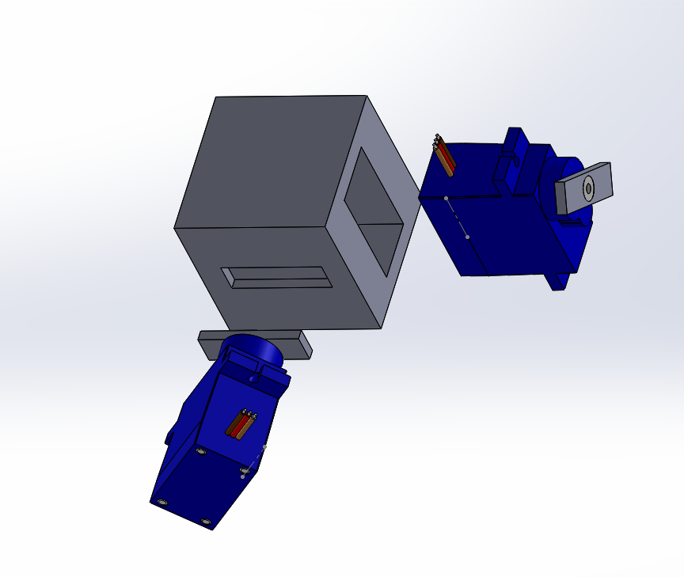

Cube

2 Servos

This subassembly (for simplicity’s sake, let’s call it the **“main joint”**) will be the main and most important components of the arm as it is used in the shoulder area as well.

This of course is not the final model of the “main joint”, the shape of the cube will be revised, and will undoubtedly take a more circular shape.

Also the hand design itself will NOT be used, it is here just for showing purposes.

**Onto the elbow joint:**

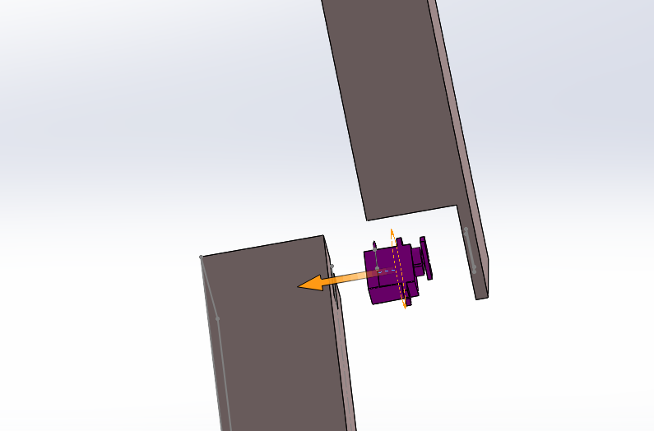

The elbow joint isn’t the same as the main joint as It only involves one motion ( rotation around the x- axis, refer to the images in page 1), hence only one servo and one hole in both arm sections are required.

The lower part of the servo will be attached to the upper Arm section while the head of the servo will be attached to the lower part of the arm.

A drawing section will be available at the end of this documents with all the measurements required ( Note : these of course are not the final measurements !).

**Finally the shoulder joint:**

The shoulder joint is very similar to the hand joint, it is actually the same :

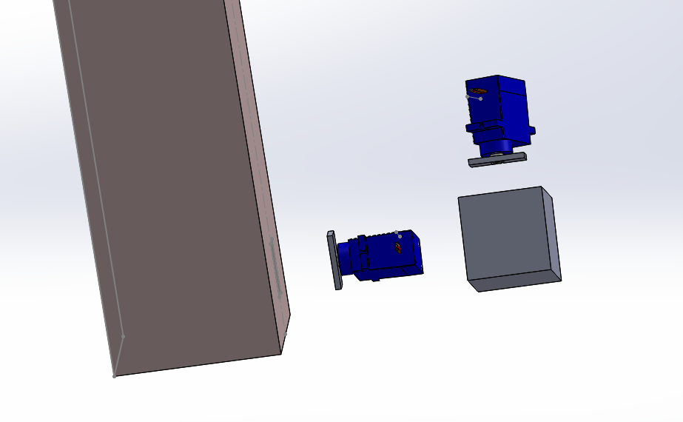

Upper arm

Main joint subassembly

One servo ( right side) will be attached to the upper arm while the other one ( bottom) will be attached to the robot body. We still haven’t designed the body, so for now we’re still working on way to attach the arm to the body while still allowing rotation around the x and z axis.

**A few side notes:**

* The servo used in the cad drawing is the **9g Micro Servo Motor (4.8V), here are its dimensions:**

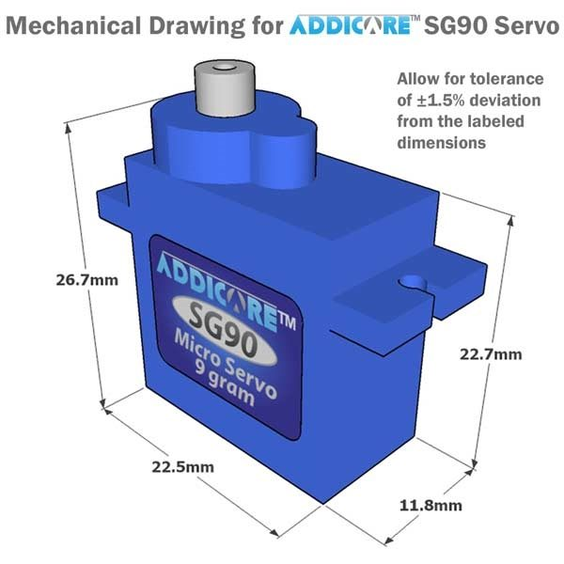

**Drawings Sections:**

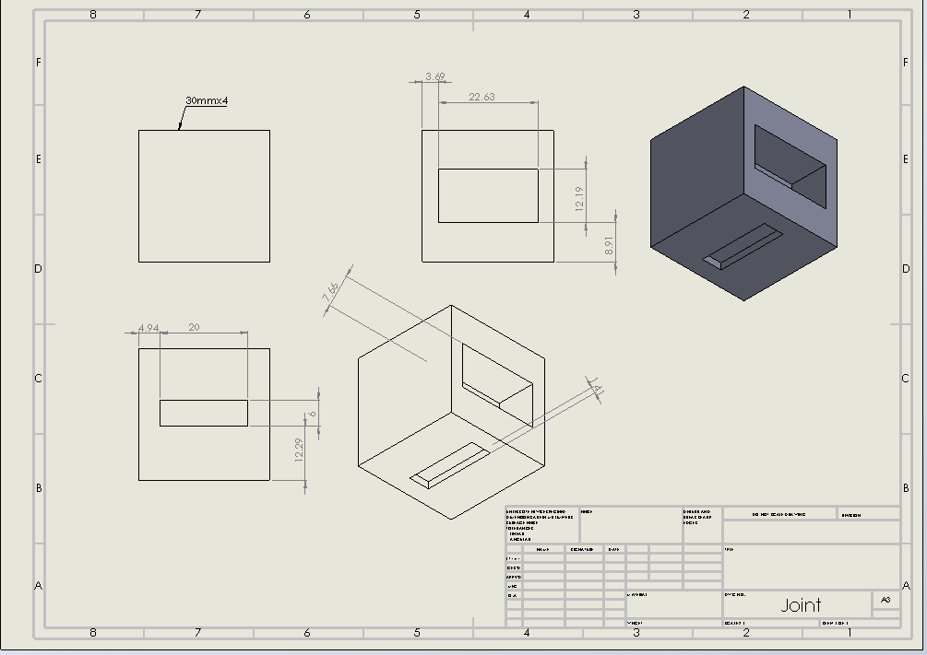

Drawing and dimensions of the cube ( in main joint assembly) :

Dimensions in millimeter.

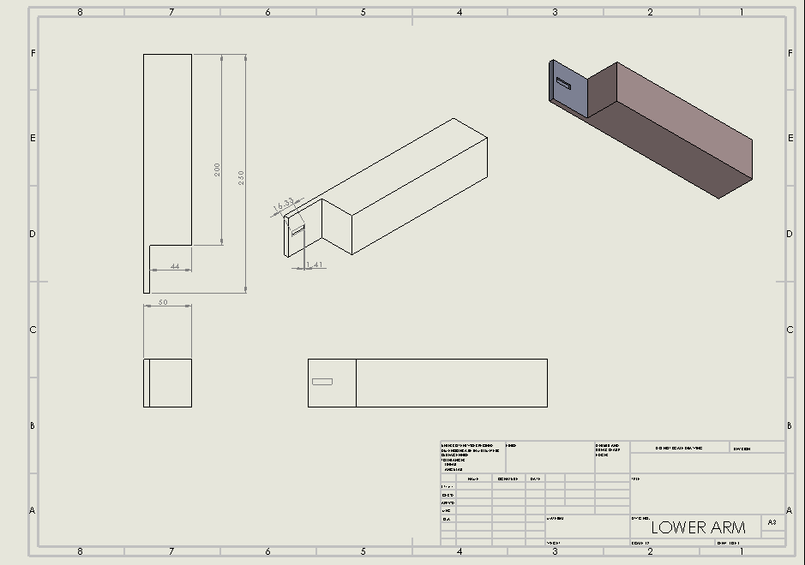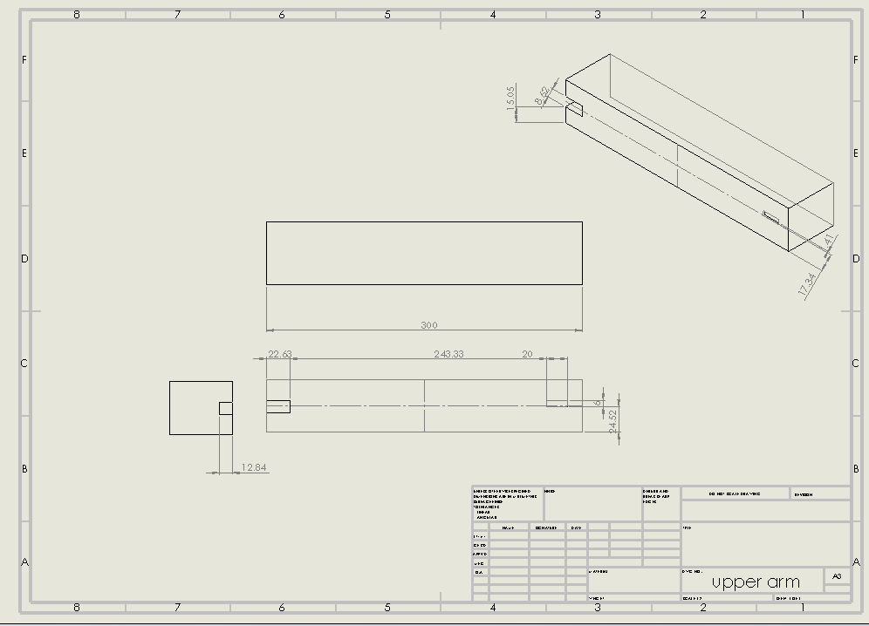

Lower Arm drawing:

Upper Arm drawing:

**Next Step :**

* Optimize the main joint
* Optimize the Upper and lower arms parts
* Identify the servo needed and the materials needed.